INS3121
SOIL MECHANICS
MAKE UP EXAM
24.12.2014

Name Surname:
Q.1 | Q.2 | Q.3 | Q.4 | Q.5 | TOTAL
Number:
Group:

- a) What is Darcy’s law? Explain.

- Sieve analysis and Atterberg limits test results of a soil specimen are given in the following table. Classify this soil considering “Unified Soil Classification System (USC)” and “Highway Soil Classification System (AASHTO)”.

Sieve # | Finer % |  | W_{L} (%) | 38
4 | 60 |  | W_{P} (%) | 17
10 | 12 |  | D₁₀ (mm) | 0.02
40 | 32 |  | D₃₀ (mm) | 0.2
200 | 4 |  | D₆₀ (mm) | 1.34

Name Surname: Number: Group:
- For an earth fill, unit weight of soil (γ) = 2.1 t/m³, moisture content (w) = 12 %, and unit weight of soil solids (γ_{s}) = 2.7 t/m³. Accordingly, calculate dry unit weight of soil (γ_{d}), porosity, and degree of saturation (S).

- Major and minor principal stresses are given as σ₁ = 120 kPa and σ₃ = 50 kPa. Determine the normal stress (σ) and shear stress (τ) on the plane which inclined 45 degree counterclockwise from the horizontal.

Name Surname: Number: Group:
- A flow net is shown for a dam in the figure. The permeability of soil (k) = 1.96x10⁻³ cm/sn.
- Compute the flow rate q.
- Compute the water pressures at point A, B, and C.

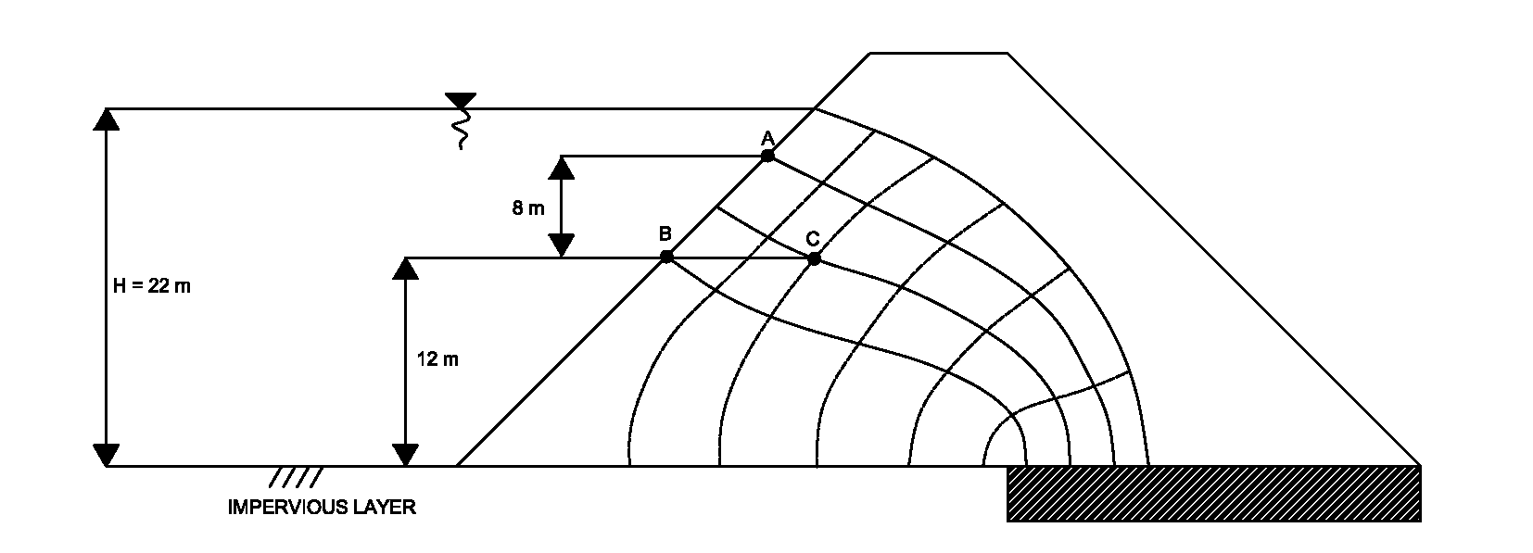

Name Surname: Number: Group:
- a) A soil profile and foundation are shown in the following figure. The settlement of clay layer at
center of foundation of 0.02 m is allowed. Calculate the load (Q) carried by foundation.
- In laboratory consolidation test, clay specimen from in-situ was tested and 50 % consolidation was accomplished in 10 minutes. Accordingly, how long does it take to reach settlement of 0.02 m?
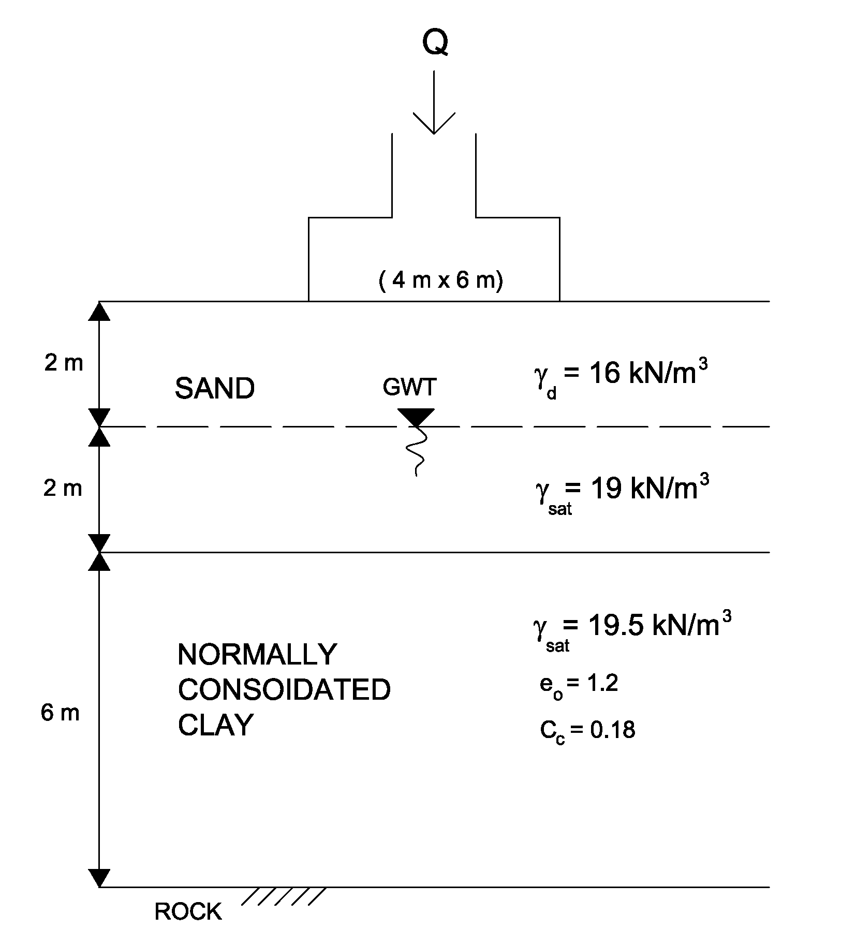
U (%) | T
10 | 0.008
20 | 0.031
30 | 0.071
40 | 0.126
50 | 0.197
60 | 0.287
70 | 0.408
80 | 0.567
90 | 0.848

Time75 minutes. Good Luck…

